Handheld Viewer Operation

- For best results, darken room and provide a black background 6-8 inches (150-200mm) below cell.
- Turn on power switch.
- Hold viewer with switch facing down.
- Place magnet on top of glass cell.
- Leave in position until image manifests.
- Rotate & flip magnet position to see other aspects of field.

Alternately:
- Place plastic magnet stand on flat surface with black background.
- Place magnet on top of stand.
- Move viewer glass down close- almost touching magnet.
- Hold in position until image manifests.
- Move viewer away and rotate magnet position.
- Notice now the field has changed with the magnets orientation.

Wait 10-30 seconds for the image to manifest. Move magnets position often.
Resting magnet in one position for long periods of time may burn the inside surface of the glass, creating a blurred view in the affected area.

Battery removal:
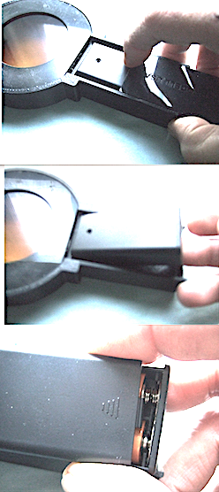

Slide cover away from cell

Lift end of battery holder from handle

Slide top cover toward cell.
Remove and recharge batteries.
Repeat procedure in reverse after charging.

Battery charger info:

Insert battery into charger slot with (-) end facing USB plug.

Set (+) in first and firmly press in (–) last. Remove in opposite order: (-) end first.

Recharge time for both batteries is approx. 55 hours from complete discharge of cells.

